Deep Learning Lab 4

# =====================================================
# EMAIL CLASSIFICATION
# Multiple Learning Rates
# Accuracy Graph and Loss Graph (Separate)
# =====================================================

import pandas as pd
import numpy as np
import matplotlib.pyplot as plt

from sklearn.model_selection import train_test_split
from sklearn.feature_extraction.text import TfidfVectorizer
from sklearn.linear_model import SGDClassifier
from sklearn.metrics import accuracy_score, log_loss

# -----------------------------
# 1. Load Dataset
# -----------------------------
df = pd.read_csv("/content/spam_or_not_spam.csv")

X_text = df["email"].fillna("")
y = df["label"]

# -----------------------------
# 2. Train-Test Split
# -----------------------------
X_train_text, X_test_text, y_train, y_test = train_test_split(
X_text, y,
test_size=0.2,
random_state=42,
stratify=y
)

# -----------------------------
# 3. TF-IDF Vectorization
# -----------------------------
vectorizer = TfidfVectorizer(max_features=5000, stop_words='english')
X_train = vectorizer.fit_transform(X_train_text)
X_test = vectorizer.transform(X_test_text)

# -----------------------------
# 4. Multiple Learning Rates
# -----------------------------
learning_rates = [0.0001, 0.001, 0.01, 0.1]
epochs = 20

accuracy_results = {}
loss_results = {}

for lr in learning_rates:

model = SGDClassifier(
loss="log_loss",
learning_rate="constant",
eta0=lr,
max_iter=1,
warm_start=True,
random_state=42
)

accuracies = []
losses = []

for epoch in range(epochs):
model.fit(X_train, y_train)

y_pred = model.predict(X_test)
y_prob = model.predict_proba(X_test)

acc = accuracy_score(y_test, y_pred)
loss = log_loss(y_test, y_prob)

accuracies.append(acc)
losses.append(loss)

accuracy_results[lr] = accuracies
loss_results[lr] = losses

# -----------------------------
# 5. Accuracy Graph
# -----------------------------
plt.figure()
for lr in learning_rates:
plt.plot(range(1, epochs+1), accuracy_results[lr], label=f"LR={lr}")

plt.xlabel("Epochs")
plt.ylabel("Accuracy")
plt.title("Accuracy vs Epochs for Different Learning Rates")
plt.legend()
plt.show()
print("\n")

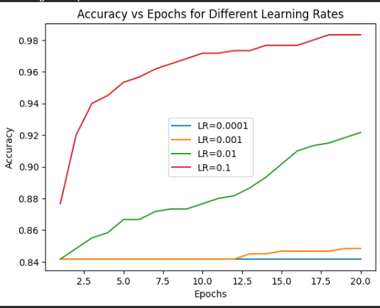

# -----------------------------
# 6. Loss Graph
# -----------------------------
plt.figure()
for lr in learning_rates:
plt.plot(range(1, epochs+1), loss_results[lr], label=f"LR={lr}")

plt.xlabel("Epochs")
plt.ylabel("Log Loss")
plt.title("Loss vs Epochs for Different Learning Rates")
plt.legend()
plt.show()

